- 单项选择。
( )1.—What is it? —It is apple.[来源:学_科_网]
A.a B.an C./
( )2.—Look at my pictures, Mike. —
A.How nice! B.Thank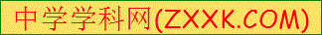 you. C.Nice to meet you.[来源:Zxxk.Com]
( )3.— is that boy? —He is my cousin Andy.
A.What B.How C.Who
( )4.—What are ? —They are pencils.
A.those B.is C.that
( )5.—Is it a duck? —Yes,
A.it isn’t B.it is C.they aren’t

